**Project Proposal: *Developing a toolset for the CAVE VR suite***

**Motivation and rationale**

Newcastle University possesses a CAVE virtual reality suite, which is both a highly valuable and massively useful piece of equipment. However, its use is presently being disadvantaged by certain features of the current system.

* Many users of the suite find it very difficult to operate, often rendering the hardware unusable until a technician is available to resolve these difficulties. It can be particularly awkward and time-consuming to determine the fault given that there are simply so many possible features or elements that could have malfunctioned.
* The current system is somewhat complex to develop for as it requires stereotypically ‘hardcore’ programming languages to function: any users with just a general knowledge of programming may not be able to understand their use.
* In the same way, testing programs for the system can be particularly tricky as it generally isn’t possible to run the CAVE version of a program elsewhere, meaning that the CAVE itself must be used for testing.

Due to the arrival of newer technologies such as WebGL, there is now the option to develop a new system for the suite. Utilising these will help to provide future-proofing, as well as allowing the suite to be used to its fullest potential and maximising the investment that the university has made in acquiring it.

The overall need that is being addressed by this proposal is the necessity for a single, unified and easy-to-use system. Furthermore, if my system can conceivably work through a web browser this would eliminate the necessity for developers to have knowledge of memory allocation or C/C++ in order to create content for the suite. By implementing this, it will not only be the commonplace users that will benefit, but also the technicians that overlook its use, as well as developers. Similarly, a streamlined development pipeline will, in turn, make it easier to develop models and environments for use within the CAVE.

This particular project is attractive to me because: it will give me a substantial insight into the sector of virtual reality; allow me to develop my understanding of graphics; also give me knowledge and use of several technologies that are paramount for a career related to video games.

**Aim**

To develop a fully featured toolset for the CAVE virtual reality suite, in order to make it simpler to use and more accessible for those wishing to use it in projects and studies

**Objectives**

1. Support the loading of 3D models of various types to ensure that the toolset is widely useable
2. Integrate head-tracking and collision detection when available in order to provide an immersive experience
3. Ensure that the system is capable of displaying stereoscopic images so that motion parallax and depth can be achieved
4. Provide logging of user interaction so that the suite can be a suitable location for psych studies and demos
5. Make available the navigation and exploration of 3D visualizations and models using the VR suite
6. Increase the share-ability of the CAVE through the use of the web and open source technologies. One intended method to measure this is to involve fellow students in using aspects of the system and then evaluate their opinions
7. Develop my toolset as open source so that there is the potential for other users to modify or add to the toolset at a later date. This will be measured by the requirements for a piece of open source software. I also intend to place my final solution into a public GitHub repository.

**Background**

|  |  |  |
| --- | --- | --- |
| Source | Summary | Explanation |
| Phil Heslop [1] | * Senior technician * Oversees use of Newcastle University’s CAVE virtual reality suite | As it is Phil who is in contact with the CAVE suite most of the time, I intend on consulting with him at regular intervals throughout my project in order to ensure that my solution is meeting the requirements for the system. I also anticipate discussing the success of my solution with Phil with regards to him giving his opinion on the share-ability and usability of the system, as they are relatively subjective characteristics and so the impression from someone with a detailed knowledge of the current system will be highly valuable. |
| CQ3A (Cave Quake III Arena) [2] | * Quake3 renderer * Developed specifically for the CAVE | Commonly known as the “Hello World” of virtual reality, this is the engine currently in use within the University’s CAVE. It is sufficient for producing 3D models, however it is also commercial software that is now relatively dated and restricted. |
| CAVELib™ [3] | * Virtual reality software API * Provides a platform for creating interactive three-dimensional environments for use within a CAVE | This is proprietary software that is currently used within the CAVE. It governs the task of ensuring that all of the images rendered are stereoscopic and also that these graphics are displayed correctly across each of the CAVE’s screens. My project will essentially involve me re-writing this API for a modern system. |
| WebGL [4] | * JavaScript API * Can be used to render both two and three-dimensional graphics within a web browser | This is the web equivalent of OpenGL that makes it possible to render graphics on the web without the requirement for any plug-ins. Also, like OpenGL, it is open source, meaning that it is highly accessible and documented. It is relevant to my project as it’s likely that I will be using WebGL in order to implement my solution, due to the fact that it contains the features that will allow me to create a toolset meeting the requirements for this project. |
| three.js [5] | * JavaScript library * Can be used to create and display three-dimensional graphics within a web browser. | This library is important as I intend on using it in conjunction with WebGL as it is lightweight and also open source. Again, this means it is extensively documented and supported, ensuring that it is both future proof and can be understood by those without any advanced programming or graphical knowledge. |
| [6] | * A research paper that describes how the use of virtual reality can be beneficial in locomotive design | This paper is relevant to my project as it describes one possible application of a CAVE system that is similar to one of the intended uses of my toolset, providing 3D architectural designs. It outlines using the 3D visualisation technology and stereoscopic immersion that can be achieved using a CAVE in order to design and model trains. This highlights the importance of my toolset meeting the two objectives relating to these two features, as this will ensure that it can be used for a variety of purposes, such as the one outlined in this paper. |
| [7] | * Outlines a research use-case for a CAVE system * Explains the possible benefits of using virtual reality for research | The paper describes the bespoke use of a CAVE system in order to provide physical rehabilitation exercises for patients with rheumatoid arthritis. This is relevant because one of the main aims of this toolset is to enable the CAVE to be easily used for research, meaning it should be feasible for someone to develop, using this paper as an example, a series of interactive exercises that can be displayed within the CAVE for participants to complete. |

**Diagrammatic work plan**

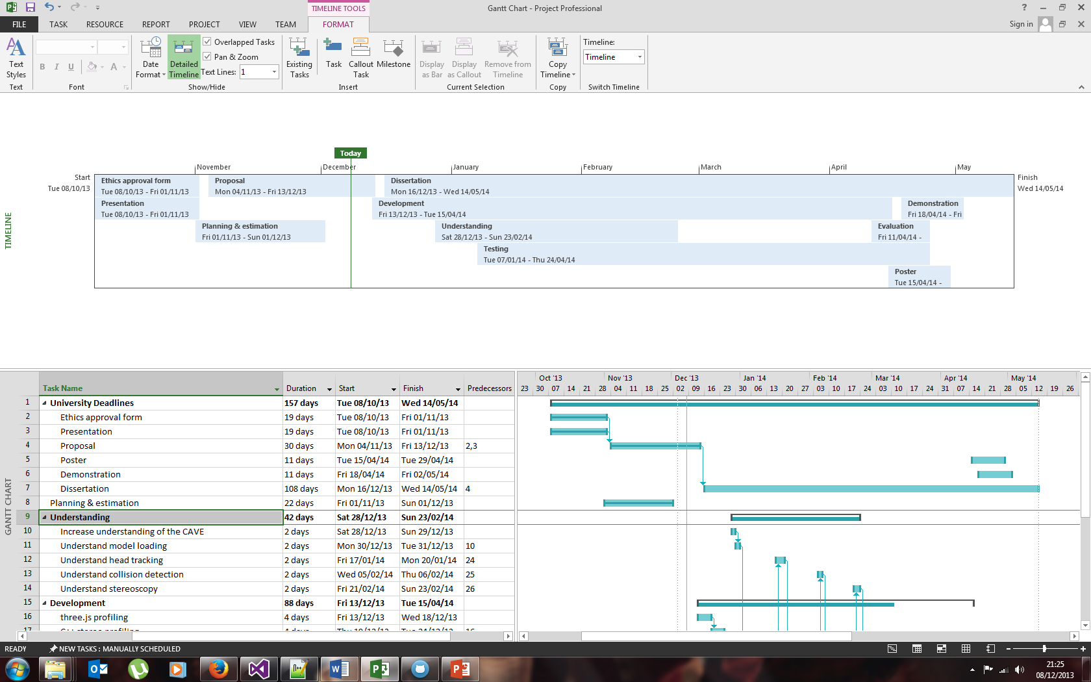

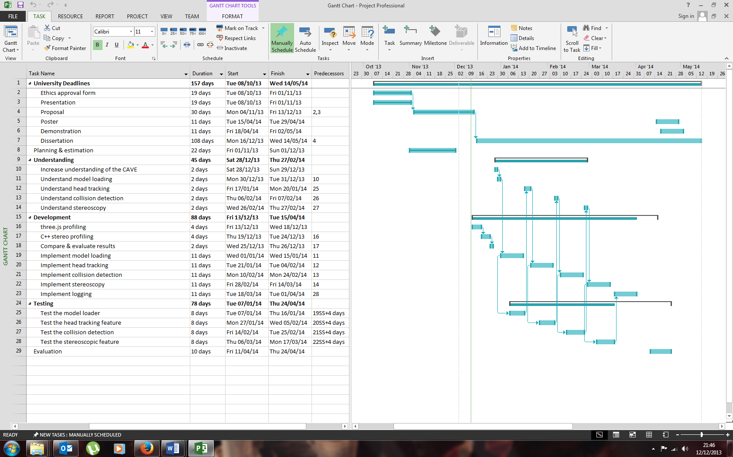

**Explanation of work plan**

In order to get a more concrete understanding of the features and requirements of the toolset that I will be creating, I have already conducted a semi-structured interview with Phil Heslop to determine how the current system functions and also any improvements that could be made.

As well as this, I’ve spent time researching into WebGL and three.js so that I have a greater knowledge of their use and capabilities. In particular, I have spent a lot of time investigating whether or not it will be possible to create a system capable of producing stereoscopic images, with WebGL and three.js in conjunction with the projectors within the university’s CAVE. This is because there are currently certain limitations with regards to WebGL (namely the fact that it is based on OpenGL ES2.0 and as such it doesn’t support quad-buffering).

Throughout my project I intend to use an agile software process model. This is because I will be implementing various features into the toolset one at a time and certain tasks have the potential to take less or more time than initially planned, as a result of issues that I may run into during development. A process model such as SCRUM allows change with ease and will ensure that my project can be organised and sufficiently planned.

As you can see from my Gantt chart, I have divided each intended feature into three distinct stages: understanding, development and testing. This has allowed me to visualise the various inter-dependencies that some of my tasks have and will assist me in completing the testing of each feature before I progress to the next ‘understanding’ task.

For the most part I plan on completing my objectives in the same order that they appear. I will first be implementing a model loader into my toolset, thus meeting my first objective. Following this I will implement head tracking, collision detection, stereoscopy and logging, in that order, allowing me to meet objectives 2, 3 and 4. Once implemented, these features comprise the requirements for meeting objective 5. Finally, objectives 6 and 7 will be met through the use of web-related and open technologies throughout my project and also releasing my end solution as open source software itself.

In general, I have anticipated the following timescale: 2 days to understand a feature; 2 calendar weeks for development; 8 days for concurrent testing (once a feature reaches ~50% completion). This allows for development and testing to be completed close to each other, ensuring that I won’t be left with large testing tasks after completing a feature before I can proceed with the next.

With regards to potential risks during my project, I intend to follow the basic premise that if a feature is taking too long to develop, i.e. it has overrun the planned implementation time, I will temporarily place it on hold so that I can then continue with another unobstructed. I believe that this is a thoughtful plan as it will ensure that upon completing my project I have a working end solution, rather than potentially having a system which doesn’t function at all if I were to spend too long on a troublesome feature.

**References**

1. *Newcastle University VR Lab*. Available at: <<http://www.iri-vr.ncl.ac.uk/>> [Last accessed November 2013]
2. Paul Rajlich, 2001. *CAVE QUAKE III ARENA.* [online] Available at: <<http://www.visbox.com/cq3a/>> [Last accessed December 2013]
3. Mechdyne, 2013. *CAVELib™.* Available at: <<http://www.mechdyne.com/cavelib.aspx>> [Last accessed December 2013]
4. The Khronos Group Inc., 2013. *WebGL – OpenGL ES 2.0 for the Web.* Available at: <<http://www.khronos.org/webgl/>> [Last accessed December 2013]
5. three.js, 2013. *three.js – JavaScript 3D library*. Available at: <<http://threejs.org/>> [Last accessed December 2013]
6. J. Seron, Diego Gutierrez, A. Magallon, J. Sobreviela, and A. Gutierrez., 2004. *A CAVE-like environment as a tool for full-size train design*. Virtual Real. 7, 2 (April 2004), 82-93. Available at: <<http://dx.doi.org/10.1007/s10055-003-0117-6>>
7. Shawn N. Gieser, Eric Becker, and Fillia Makedon, 2013. *Using CAVE in physical rehabilitation exercises for rheumatoid arthritis*. In Proceedings of the 6th International Conference on Pervasive Technologies Related to Assistive Environments (PETRA '13). ACM, New York, NY, USA, Article 30, 4 pages. Available at: <<http://doi.acm.org/10.1145/2504335.2504367>>